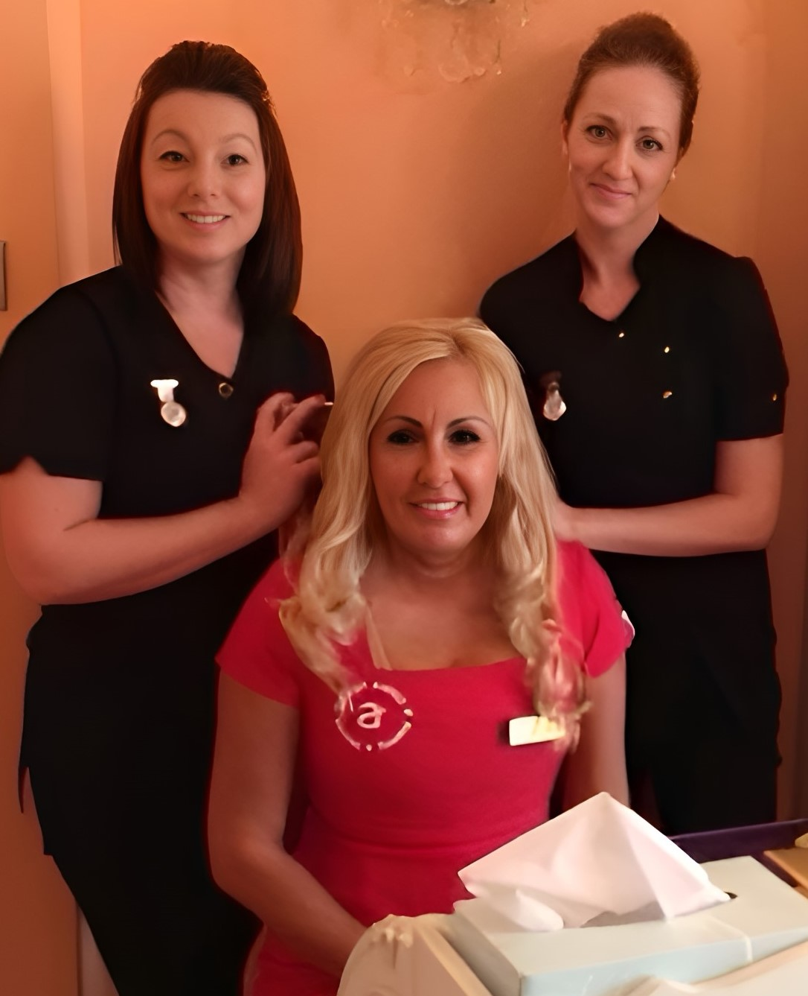
Deborah Harwood-Kelly

11 Avenue Gate, Great Woodcote Park, Loughton, Essex IG10 4QN
Tel: +44 (0)7860 727486 E-mail: debi-j@hotmail.co.uk

professional attributes

I have been a professional Tutor/Assessor and IQA since 2010 delivering L2, L3, L4, L5 and L7 for the VTCT, NVQ, VRQ ITEC, City & Guilds, BABTAC, CA, ABT and CPD accreditations. I am committed to mentoring and teaching students to become the best versions of themselves.

commercial competencies

- Experienced with creating and founding a beauty school including prospectus development, course planning, production of manuals and workbooks, and delivery at The Angel Academy of Teaching & Training. Administered staff and client scheduling for maximum revenue generation and profitability.
- Successfully launched website for The Angel Academy of Teaching & Training and coordinated search engine optimisation.
- Responsible for optimisation of all related social media including Facebook, Instagram, Blogs, Vlogs and Youtube.
- Travelled internationally to provide training to 5* spas within the Kemplinski Hotel Group training on the industry leading Danielle de Winter product range.
- Written editorial and Beauty Articles for Expert Beauty Magazine, OK Magazine and numerous related publications.
- Author of Number 1 Bestselling Books on Amazon in Beauty, Therapy and Anatomy & Physiology
- Planned and organised celebrity-based publicity events based on beauty and holistic therapies in the Serenity Spa at Repton Park maximising publicity opportunities and dealing with media.

achievements

- Successfully formed and launched new beauty and massage training school, The Angel Academy of Teaching & Training in Loughton, Essex which was featured on Sky One and ITV television shows.
- Achieved VTCT certification at The Angel Academy of Teaching & Training
- Created and launched many new courses to the market, providing maximum exposure including workshops at exhibitions such as CamExpo.
- Achieved over 67,000 views on The Angel Academy of Teaching & Training’s YouTube channel.
- Designed, developed and delivered courses, promotions, events and campaigns for commissioned beauty schools and adult education centres, bringing over 5,000 new students to their establishments.
- Successfully delivered L1-L7 Beauty and Anatomy courses online, achieving 100% pass rates, with student retention and progression onto other courses .

career history

02/2003 – Present Owner, The Angel Academy of Teaching & Training
The Angel Academy of Teaching & Training – Essex’ leading training school for massage and beauty therapies.

- Set up and management of the brand-new beauty school and clinic in Loughton offering BABTAC and FHT certification in 2003, progressing to VTCT and NVQ accreditation in 2010.
- Launch of the school and clinic to the press and external clientele
- Introduction and launch of new holistic division: Example: Heated bamboo massage
- Development of treatment menu and spa/beauty concept
- Planning internal and external marketing actions to actively promote the courses and therapies
- Managing and developing a team of 3 staff which include a medical, massage and a beauty team
- Consistently develop and grow retail sales through training, tools and monitoring and ensure the school and retail areas are staged for maximum buyer impact
- Use financial plans for spotting trends, measuring productivity and monitoring progress
- Administer staff and client scheduling for maximum revenue generation and profitability
- Project and maintain acceptable payroll commitments
- Implement opportunities for managing operational costs and boosting the bottom line
- Production and development of vegan skincare range Celebrity Red Carpet Skincare

03/2010 – Present Beauty Presenter and Actress
Forthcoming television show teaching everyone beauty skills that can be put into practice quickly and effectively with stunning results
- Organised guest experts in areas of fashion and beauty and guest clients to experience personal transformation.
- Presented and introduced in front of television cameras.

1991 – Present Commissioned Tutor
Acted as a commissioned tutor on a part time basis for numerous schools & colleges
- The British School of Complimentary Therapy (BSCT), Harley Street, London, offering diplomas and certificates
- Enfield College, offering City & Guilds.
- West Thames College, Hounslow, offering ITEC
- Redbridge College, offering VTCT
- MSCM- Middlesex School of Complementary Medicine- BABTAC
- Therapy Training School- The Guild of Holistic Therapies

1984 – 1991 Beauty Media Specialist
- Sky Television – Exhibition Sales & Marketing Manager in Beauty Industry
- OK Magazine and Northern & Shell – Field Sales & Exhibitions Manager in Beauty Industry
- Kiss FM – Account Manager for Beauty and Health Industry
- Radio Mercury, County Sound & Delta FM – Sales & Marketing Executive for Beauty Division
- The Gatwick News – Account Executive/Exhibitions for Beauty & Health Sector

workplace Skills and professional development

Diploma 7407 Teacher Training Level 2
Degree Assessors Awards A1/A2
Diploma 7407 Teacher Training Level 1
Diploma 65 Further Certifications in VTCT, NVQ, BABTAC, ITEC, IIHHT, ABT, CA, CPD, FHT & The Guild

A Level: Science In Society
A/O: Level English & Art
O Level: Maths, History, Sociology, French

Hobbies & Interests
- MUA at Fashion and Beauty Events
- Appearing on Real-life challenge/documentaries for Television
- I am interested in interior design and have designed a few houses from scratch.

